Eurotrace Access Database Conversion Utility

ConvertET.exe is a small tool you can copy and run from everywhere to convert Eurotrace Access Domain.
  - from Access 95 (v30) format to Access Compatible format (v40: can be opened under latest version of Access)
  - the new format is compatible with 3.3.28 but this version will continue to generate new file with Access 95 format (New month of declaration, etc…)
Just launch the application, you can copy this program in the C:\Eurotrace\ Folder
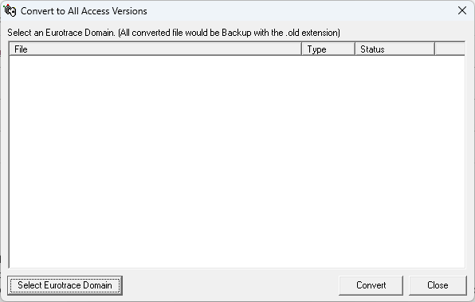
To process you must click on “Select Eurotrace Domain”: then you just must select your DOM file. (You can also change the file type to Access File to convert any access file: useful if you need to convert Eurotrace Editor (*.ETC) or the Debug database XX_1234567.tmp file).
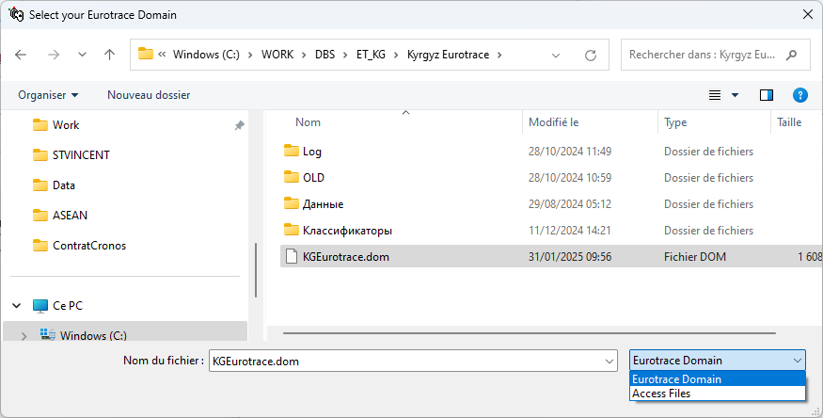
If you select a domain: the list of files to convert will be shown. Then just press the “Convert” button.
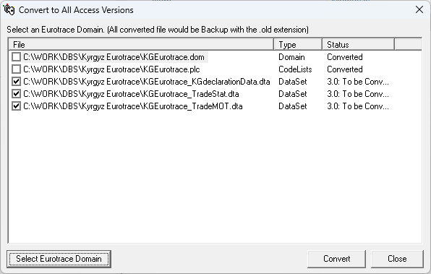
Original files are renamed with the .old extension before correction. You can restore them manually if necessary or delete them.

